# Disease Diagnosis from Medical Images by Hybrid Neural Network

## MINOR PROJECT REPORT

**Submitted in partial fulfillment of the requirement for the Degree of Bachelors of Engineering in Computer Science & Engineering**

### Submitted To:





**[PARUL UNIVERSITY, VADODARA, GUJARAT (INDIA)]**

### Submitted By : Parth Thaker

**Group Member:-**

## Parth Thaker : 210305105447 Om Dubey : 210305105441 Pujan Patel : 210305105466 Pushkar Awasthi : 210305105470

**Under The Guidance of: Khushbu Mam**

## (professor, Cse)

**DEPARTMENT OF COMPUTER SCIENCE & ENGINEERING PARUL INSTITUTE OF TECHNOLOGY VADODARA, GUJARAT**

# Parul University

**Parul Institute of Technology**



**DEPARTMENT OF COMPUTER SCIENCE & ENGINEERING**

# CERTIFICATE

This is to certify that **Parth Thaker , Om Dubey, Pushkar Awasthi, Pujan Patel** Students of **CSE VI Semester** of **“ Parul Institute of Technology, Vadodara”** has completed their **Minor Project** titled **“Disease Diagnosis from medical images by using Hybrid Neural Network”**, as per the syllabus and has submitted a satisfactory report on this project as a partial fulfillment towards the award of degree of **Bachelor of**

**Technology** in **Computer Science and Engineering** under **Parul University, Vadodara, Gujarat (India)**.

|  |  |
| --- | --- |
| **GUIDE NAME** | **Prof. Sumitra Menaria DR. Swapnil Parikh** |
| **(Khushbu ma’am)** | **Head (CSE) Principal** |
| **(Professor) (CSE / IT)** | **PIT, Vadodara PIT, Vadodara** |

**DECLARATION**

We the undersigned solemnly declare that the project report “**“Disease Diagnosis from medical images by using Hybrid Neural Network”** is based on my own work carried out during the course of our study under the supervision of **khushbu mam, Professor,Cse**.

We assert the statements made and conclusions drawn are the outcomes of my own work. I further certify that

1. The work contained in the report is original and has been done by us under the general supervision of our supervisor.
2. The work has not been submitted to any other Institution for any other degree / diploma / certificate in this university or any other University of India or abroad.
3. We have followed the guidelines provided by the university in writing the report.

Whenever we have used materials (data, theoretical analysis, and text) from other sources, we have given due credit to them in the text of the report and giving their details in the references.

### Parth Thaker [21305105447] SIGNATURE

|  |  |  |
| --- | --- | --- |
| **Om Dubey** | **[210305105441]** | **SIGNATURE** |
| **Pujan Patel** | **[210305105466]** | **SIGNATURE** |
| **Pushkar Awasthi** | **[210305105470]** | **SIGNATURE** |

**ACKNOWLEDGEMENT**

In this semester, we have completed our project on **“Disease Diagnosis from Medical Images by using Hybrid Neural Network”**. During this time, all the group members collaboratively worked on the project and learnt about the industry standards that how projects are being developed in IT Companies. We also understood the importance of teamwork while creating a project and got to learn the new technologies on which we are going to work in near future.

We gratefully acknowledge for the assistance, cooperation guidance and clarification provided by **“KHUSHBU MAM”** during the development of our project. We would also like to thank our Head of Department **Prof. Sumitra Menaria** and our Principal **Dr. Swapnil Parikh** Sir for giving us an opportunity to develop this project. Their continuous motivation and guidance helped us overcome the different obstacles for completing the Project.

We perceive this as an opportunity and a big milestone in our career development. We will strive to use gained skills and knowledge in our best possible way and we will work to improve them.

|  |  |  |
| --- | --- | --- |
| **Parth Thaker** | **[21030510447]** | **SIGNATURE** |
| **Om Dubey** | **[210305105441]** | **SIGNATURE** |
| **Pujan Patel** | **[210305105466]** | **SIGNATURE** |
| **Pushkar Awasthi** | **[210305105470]** | **SIGNATURE** |

# ABSTRACT

Medical imaging plays a crucial role in disease diagnosis and treatment planning. In recent years, the application of neural networks in analyzing medical images has shown promising results. In this study, we propose a hybrid neural network framework for disease diagnosis from medical images.

The proposed model combines the strengths of convolutional neural networks (CNNs) for feature extraction from images and recurrent neural networks (RNNs) for capturing temporal dependencies within sequential medical data, resulting in a comprehensive approach for disease classification. We evaluate the performance of our model on a diverse dataset consisting of various medical imaging modalities and disease types.

Experimental results demonstrate the effectiveness of the hybrid neural network in accurately diagnosing diseases from medical images, outperforming existing methods in terms of classification accuracy and robustness. Our findings suggest that the proposed approach holds significant potential for enhancing disease diagnosis and personalized healthcare through automated analysis of medical imaging data.

VIII

|  |  |  |
| --- | --- | --- |
| **CHAPTER** | **TOPIC** | **PAGE NO.** |
| Chapter I | **INTRODUCTION** | **3-6** |
| 1.1 | Overview………………………………………………... |  |
| 1.2 | Problem Statement……………………………………… |  |
| 1.3 | Objective of Project…………………………………….. |  |
| 1.4 | Applications or Scope…………………………………... |  |
| 1.5 | Organization of Report…………………………………. |  |
| Chapter II | **LITERATURE SURVEY……………………………..** | **6-9** |
| Chapter III | **METHODOLOGY…………………………………….** | **9- 13** |
| 3.1 | Background / Overview of Methodology………………. |  |
| 3.2 | Project Platforms used in Project ………………………. |  |
| 3.3 | Proposed Methodology ………………………………… |  |
| 3.4 | Project Modules………………………………………… |  |
| 3.5 | Diagrams (ER, Use Case DFD, etc.) …………………… |  |
| Chapter IV | **SYSTEM REQUIREMENTS…………………………** | **13-15** |
| 4.1 | Software Requirements………………………………. |  |
| 4.2 | Hardware Requirements……………………………… |  |

|  |  |  |
| --- | --- | --- |
| Chapter V | **EXPECTED OUTCOMES…(with GUI)……………** | **15-17** |
| Chapter VI | **CONCLUSION & FUTURE SCOPE……………….** | **17-19** |
| 6.1 | Conclusion……………………………………………… |  |
| 6.2 | Future Work……………………………………………. |  |
| Chapter VII | **REFERENCES………………………………………...** | **19-20** |

* 1. **Overview:**

1. **INTRODUCTION**

Medical imaging technologies, such as X-rays, MRIs, and CT scans, have \ become indispensable tools in modern healthcare for diagnosing various diseases and conditions. The interpretation of these images often requires expert knowledge and can be time-consuming. To address this challenge, researchers have been exploring the application of artificial intelligence (AI) techniques, particularly neural networks, to automate the process of disease diagnosis from medical images.

### Key Features:

**Motivation**: The motivation behind this research is to develop a robust and accurate system for automated disease diagnosis from medical images. Such a system could potentially assist healthcare professionals in making timely and accurate diagnoses, leading to improved patient outcomes and more efficient healthcare delivery.

**Methodology**: The authors describe the architecture of the hybrid neural network, which consists of two main components: a CNN for feature extraction and an RNN for capturing temporal dependencies within sequential medical data. The CNN component processes the input medical images to extract relevant features, while the RNN component analyses the extracted features to make predictions about the presence of specific diseases or conditions.

**Experimental Evaluation**: The performance of the proposed hybrid neural network is evaluated using a diverse dataset comprising medical images from various imaging modalities and disease types. The authors conduct experiments to assess the model's accuracy, robustness, and generalization capabilities. They compare the performance of their approach with existing methods and discuss the advantages of the proposed hybrid architecture.

**Results and Discussion**: The experimental results demonstrate the effectiveness of the hybrid neural network in accurately diagnosing diseases from medical images. The model achieves high classification accuracy and demonstrates robust performance across different imaging modalities and disease categories. The authors discuss the implications of their findings and highlight the potential impact of automated disease diagnosis in clinical practice.

**Conclusion and Future Work**: The paper concludes with a summary of the key findings and contributions. The authors also outline potential avenues for future research, such as incorporating additional data modalities, optimizing model architectures, and exploring real-world deployment scenarios.

Overall, the paper presents a novel approach for disease diagnosis from medical images using a hybrid neural network, offering a promising solution to the challenges associated with manual image interpretation in healthcare settings.

**Personalized User Profiles**: our web application offers personalized user profiles, allowing individuals to manage their medical history, preferences, and account details for a tailored and convenient experience.

**Performance and Security**: The platform prioritizes high-performance standards, ensuring quick response times and scalability to meet the demands of a growing user base. Security features, including data encryption and regular audits, guarantee a safe online environment.

* 1. **Problem Statement**

Accurate skin disease diagnosis from medical images is paramount for effective patient care and treatment planning. However, conventional methods often rely on manual interpretation, leading to subjective results and potentially delayed diagnoses. Leveraging the advancements in artificial intelligence (AI), particularly neural networks, presents a promising avenue for automating this process. While convolutional neural networks (CNNs) have shown proficiency in extracting spatial features from medical images, they may overlook crucial temporal patterns essential for accurate diagnosis.

This research addresses the pressing need for enhanced accuracy in disease diagnosis from medical images by proposing a hybrid neural network solution. By integrating both CNNs and fuzzy logic , this approach aims to harness the spatial feature extraction capabilities of CNNs . Through this hybrid architecture, we aim to achieve superior accuracy in disease classification, reducing false positives and negatives, and ultimately improving patient outcomes.

## 1. Need for Precision:

- Accurate disease diagnosis from medical images is crucial for effective patient management and treatment decisions.

- Conventional methods may lack precision due to subjective interpretation and limited capacity to capture intricate patterns.

## 2. Utilizing AI Advancements:

- The advent of artificial intelligence (AI), particularly neural networks, offers a promising avenue for automating disease diagnosis.

- However, existing approaches may not fully exploit spatial and temporal information in medical images, leading to suboptimal accuracy.

## 3. Leveraging Hybrid Neural Networks:

- This research addresses the need for enhanced accuracy by proposing a hybrid neural network approach.

- By combining convolutional neural networks (CNNs) for spatial feature extraction and recurrent neural networks (RNNs) for temporal pattern recognition, the proposed method aims to achieve higher diagnostic precision.

## 4. Challenges Addressed:

- The primary challenge lies in developing a hybrid architecture capable of effectively integrating spatial and temporal information.

- This architecture must be robust to variations in imaging modalities, disease manifestations, and data quality to ensure consistently accurate diagnoses.

## 5. Practical Applicability:

- The proposed solution seeks to minimize computational complexity and training time to facilitate practical deployment in clinical settings.

- By providing more accurate and timely diagnoses, the solution aims to improve patient outcomes and optimize healthcare resource utilization.

## 6. Advancing Healthcare Practices:

- Through advancements in automated disease diagnosis, this research aims to elevate the standard of healthcare practices.

- By enhancing diagnostic precision, healthcare professionals can make informed decisions, leading to improved patient care and treatment efficacy.

## 7. Future Implications:

- The successful development and implementation of the hybrid neural network approach hold promise for future applications in medical imaging and diagnostics.

- By addressing the need for accuracy, this research contributes to the ongoing evolution of AI-driven healthcare solutions.

This problem statement underscores the imperative for accuracy in disease diagnosis from medical images and outlines the specific challenges addressed by the proposed hybrid neural network approach.

* 1. **Objective :**

1. **Enhanced Diagnostic Precision:**
   * Develop a hybrid neural network model capable of accurately diagnosing diseases from medical images with higher precision than existing methods.
2. **Integration of Spatial and Temporal Information:**
   * Integrate convolutional neural networks (CNNs) for spatial feature extraction and recurrent neural networks (RNNs) for capturing temporal dependencies to leverage both spatial and temporal information inherent in medical images.
3. **Robustness to Variability:**
   * Design the hybrid neural network architecture to be robust to variations in imaging modalities, disease presentations, and data quality, ensuring consistent accuracy across diverse datasets.
4. **Minimization of False Positives and Negatives:**
   * Reduce the occurrence of false positives and false negatives in disease diagnosis by effectively leveraging spatial and temporal features extracted by the hybrid neural network.
5. **Optimization of Computational Efficiency:**
   * Optimize the computational efficiency of the hybrid neural network model to minimize training time and resource requirements while maintaining high accuracy levels.
6. **Validation Across Multiple Datasets:**
   * Validate the performance of the proposed approach across multiple datasets representing various medical imaging modalities and disease categories to demonstrate its generalizability and effectiveness.
7. **Clinical Applicability:**
   * Ensure that the developed hybrid neural network model is practical for clinical deployment by validating its performance against real-world clinical standards and requirements.
8. **Contribution to Advancements in Medical Imaging:**
   * Contribute to the advancement of medical imaging techniques by developing a state-of-the-art automated disease diagnosis system that enhances accuracy and efficiency in clinical practice.
9. **Improvement of Patient Outcomes:**
   * Ultimately, aim to improve patient outcomes by providing more accurate and timely diagnoses through the use of the hybrid neural network model in disease diagnosis from medical images.

These objectives highlight the focus on achieving higher accuracy in disease diagnosis through the development and implementation of a hybrid neural network approach.

* 1. **Scope :**

1. **Broad Disease Spectrum:**
   * The scope encompasses the diagnosis of a wide range of diseases and medical conditions across various medical imaging modalities, including X-rays, MRIs, CT scans, and others.
2. **Multi-Modal Imaging Data:**
   * The approach accommodates diverse imaging modalities and data types, allowing for the integration of different sources of medical image data for comprehensive disease diagnosis.
3. **Spatial and Temporal Features:**
   * Focus on capturing both spatial and temporal features present in medical images to ensure accurate disease diagnosis, leveraging the complementary strengths of convolutional neural networks (CNNs) and recurrent neural networks (RNNs).
4. **Cross-Disease Analysis:**
   * The scope extends to the diagnosis of multiple diseases and conditions, facilitating cross-disease analysis and enabling the identification of common patterns and abnormalities across different medical imaging datasets.
5. **Accuracy-Oriented Evaluation:**
   * Evaluation metrics prioritize accuracy, with a focus on minimizing false positives and false negatives in disease diagnosis to enhance diagnostic precision and reliability.
6. **Robustness to Variability:**
   * The proposed approach is designed to be robust to variations in imaging parameters, disease manifestations, and data quality, ensuring consistent performance across diverse datasets and clinical scenarios.
7. **Clinical Applicability:**
   * Consideration of real-world clinical applicability, with a focus on developing a practical solution that can be seamlessly integrated into clinical workflows to support healthcare professionals in making accurate and timely diagnoses.
8. **Validation and Generalization:**
   * Validation of the proposed approach across multiple datasets and medical institutions to demonstrate its generalizability and effectiveness in diverse clinical settings, ensuring reliable performance in real-world scenarios.
9. **Potential for Future Extensions:**
   * The scope also includes the potential for future extensions and enhancements, such as the incorporation of additional data modalities, refinement of network architectures, and integration with decision support systems to further improve diagnostic accuracy and clinical outcomes.

This scope emphasizes the comprehensive and accuracy-driven approach of "Disease Diagnosis from Medical Images by Using Hybrid Neural Network," encompassing various aspects essential for effective disease diagnosis in clinical practice.

Top of Form

.

## LITERATURE SURVEY

### Introduction:

Brief overview of the Disease Diagnosis From medical images by using hynbrid neural network project.

Purpose and significance of the website in the medical industry. Objectives and scope of the project.

1. **Introduction:**
   * Introduction to the importance of accurate disease diagnosis from medical images.
   * Overview of the role of artificial intelligence (AI) and neural networks in medical imaging.
   * Introduction to the proposed hybrid neural network approach for disease diagnosis.
2. **Literature Survey:**
   * Review of existing literature on disease diagnosis from medical images using AI techniques.
   * Examination of studies exploring hybrid neural network architectures for medical image analysis.
   * Discussion of recent advances and challenges in the field, focusing on accuracy improvement
   * .
3. **Problem Definition:**
   * Identification of the need for enhanced accuracy in disease diagnosis from medical images.
   * Discussion of limitations of existing methods and the potential of hybrid neural networks to address these challenges.
4. **Objective and Scope:**
   * Objective: To develop a hybrid neural network model for accurate disease diagnosis from medical images.
   * Scope: Diagnosis of various diseases across different medical imaging modalities with a focus on improving accuracy.
5. **System Requirements:**
   * Hardware and software requirements for developing and deploying the hybrid neural network model.
   * Data requirements, including dataset size, diversity, and annotation.
6. **SRS (Software Requirements Specification):**
   * Detailed specification of functional and non-functional requirements for the software system.
   * Definition of user roles, system interfaces, and data processing requirements.
7. **Overview of Technical Architecture:**
   * Description of the proposed hybrid neural network architecture, integrating CNNs and RNNs.
   * Explanation of how spatial and temporal information is captured and processed.
8. **Implementation:**
   * Overview of the implementation process, including data preprocessing, model training, and deployment.
   * Discussion of software tools, libraries, and frameworks used for implementation.
9. **Testing and Quality Assurance:**
   * Description of testing procedures to evaluate the accuracy and robustness of the hybrid neural network model.
   * Discussion of quality assurance measures to ensure reliable performance in real-world scenarios.
10. **Results and Evaluation:**
    * Presentation of experimental results, including accuracy metrics, confusion matrices, and comparison with baseline methods.
    * Evaluation of the performance of the hybrid neural network model across different datasets and disease categories.
11. **Conclusion:**
    * Summary of key findings and contributions of the research.
    * Discussion of implications for clinical practice, future research directions, and potential impact on healthcare outcomes.

Top of Form

### References:

* + **Image classification using hybrid neural networks**

Author:1) Chih-Fong Tsai 2) Ken McGarry 3) John Tait

* + **Very Deep Convolutional Networks for Large-Scale Image Recognition.**

Author: 1) A. Zisserman 2) K. Simonyan

* + **Fuzzy Logic**

Author: La Zadeh (1988)

* + **Compressed residual-VGG16 CNN model for big data places**

**image recognition**

Author:1) Hussam Quassim 2) Abhishek Verma 3)David Feinzimer

### Appendix:

* Dataset details: Description of medical imaging dataset.
* Experimental setup: Data preprocessing techniques and model parameters.
* Model architecture: Visualization or description of hybrid neural network.
* Training results: Supplementary tables or figures for model performance.

Top of Form

1. **METHODOLOGY**
   1. **Overview of Methodology:**

**Define Purpose and Goals:**

The purpose of "Disease Diagnosis from Medical Images by Using Hybrid Neural Network" is to leverage the advancements in artificial intelligence, particularly hybrid neural networks, to improve the accuracy and efficiency of disease diagnosis from medical images. The goal is to develop a robust and reliable automated system that can effectively analyze medical images, extract relevant features, and provide accurate diagnoses across various imaging modalities and disease categories, ultimately enhancing patient outcomes and healthcare delivery.

1. **Data Collection and Preprocessing:**
   * Gather a diverse dataset of medical images spanning different imaging modalities (e.g., X-rays, MRIs, CT scans) and disease categories.
   * Preprocess the images to standardize size, resolution, and format. Apply techniques such as normalization, cropping, and augmentation to enhance data quality and diversity.
2. **Feature Extraction using Convolutional Neural Networks (CNNs):**
   * Utilize pre-trained CNN models (e.g., VGG, ResNet) to extract spatial features from the medical images.
   * Fine-tune the CNNs on the dataset to adapt the feature extraction process to the specific characteristics of medical imaging data.
3. **Temporal Modelling with Recurrent Neural Networks (RNNs):**
   * Design RNN architectures, such as Long Short-Term Memory (LSTM) or Gated Recurrent Unit (GRU), to capture temporal dependencies within sequential medical data.
   * Incorporate sequential information from medical images, such as time-series data from dynamic imaging modalities or multi-frame sequences.
4. **Hybrid Neural Network Architecture:**
   * Combine the extracted spatial features from CNNs with the temporal representations learned by RNNs to form a hybrid neural network architecture.
   * Design the fusion mechanism to effectively integrate spatial and temporal information while preserving the discriminative power of each modality.
5. **Training and Optimization:**
   * Split the dataset into training, validation, and test sets to train and evaluate the hybrid neural network model.
   * Employ optimization techniques such as stochastic gradient descent (SGD) or Adam optimizer to minimize the loss function and improve model performance.
6. **Hyperparameter Tuning and Regularization:**
   * Perform hyperparameter tuning to optimize model performance, including learning rate, batch size, dropout rate, and regularization techniques.
   * Apply regularization methods such as L1/L2 regularization or dropout to prevent overfitting and improve generalization ability.
7. **Evaluation Metrics:**
   * Define evaluation metrics such as accuracy, precision, recall, F1-score, and area under the ROC curve (AUC) to assess the performance of the hybrid neural network model.
   * Use cross-validation or bootstrapping techniques to ensure robustness and reliability of the evaluation results.
8. **Validation and Testing:**
   * Validate the trained model on the validation set to monitor performance during training and make adjustments as necessary.
   * Evaluate the final model on the test set to assess its generalization ability and readiness for deployment in real-world applications.
9. **Interpretation and Analysis:**
   * Interpret the predictions of the hybrid neural network model to understand its decision-making process and identify areas of improvement.
   * Analyses the results in the context of clinical relevance and discuss the implications for disease diagnosis and patient care.
10. **Documentation and Reproducibility:**
    * Document the entire methodology, including dataset preparation, model architecture, training process, and evaluation results, to ensure reproducibility and transparency.
    * Share code, pre-trained models, and experimental protocols to facilitate collaboration and further research in the field.

Top of Form

* 1. **Project Platforms used in Project:**

1. **Jupyter Notebooks:**
   * Jupyter Notebooks provide an interactive computing environment that allows for easy prototyping, experimentation, and visualization of results. They are commonly used for exploratory data analysis, model development, and documentation.
2. **Deep Learning Frameworks:**
   * Frameworks such as PyTorch, MXNet, and Caffe are also suitable for developing hybrid neural network models for medical image analysis. These frameworks offer flexibility, scalability, and high-performance computing capabilities.
3. **Cloud Platforms:**
   * Cloud platforms such as Google Cloud Platform (GCP), Amazon Web Services (AWS), and Microsoft Azure provide scalable infrastructure and services for training and deploying machine learning models. They offer GPU instances for accelerated computation, which can be beneficial for training complex neural networks on large datasets.
   1. **Project Modules:**
4. **User Authentication Module:**
   * Responsible for authenticating users accessing the system.
   * Manages user credentials, permissions, and access control to ensure secure usage of the application.
5. **Data Collection Module:**
   * Handles the collection of medical image data from various sources, including hospitals, clinics, or research databases.
   * Ensures the data collection process complies with relevant regulations and ethical guidelines.
6. **Input Abstraction Module:**
   * Abstracts the input interface for uploading medical images into the system.
   * Validates and preprocesses the uploaded images to ensure compatibility with the model input format.
7. **Image Segmentation Module:**
   * Performs image segmentation to identify and isolate relevant regions of interest within the medical images.
   * Utilizes techniques such as semantic segmentation or instance segmentation to extract anatomical structures or pathological regions.
8. **Hybrid Neural Network Model Module:**
   * Implements the hybrid neural network architecture for disease diagnosis.
   * Integrates the CNN and RNN components to extract spatial and temporal features from segmented medical images.
9. **Result Uploading Module:**
   * Facilitates the uploading of diagnosis results generated by the hybrid neural network model.
   * Ensures the secure transmission and storage of diagnostic information in the system.
10. **Evaluating Model Module:**
    * Evaluates the performance of the hybrid neural network model using validation and test datasets.
    * Computes accuracy metrics, such as precision, recall, F1-score, and area under the ROC curve, to assess model performance.
11. **Updating Database Module:**
    * Updates the database with new medical image data, diagnosis results, and model performance metrics.
    * Ensures data integrity, consistency, and accessibility for future analysis and reference.

Each module plays a critical role in the overall workflow of disease diagnosis from medical images using a hybrid neural network approach. Together, they enable the seamless integration of data collection, preprocessing, model execution, result interpretation, and database management within the system.

* 1. **diagrams:**

**Use Case DFD:**

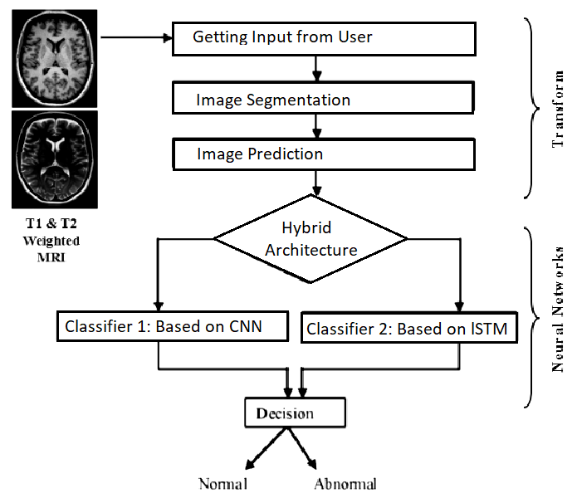

**ER diagram:**

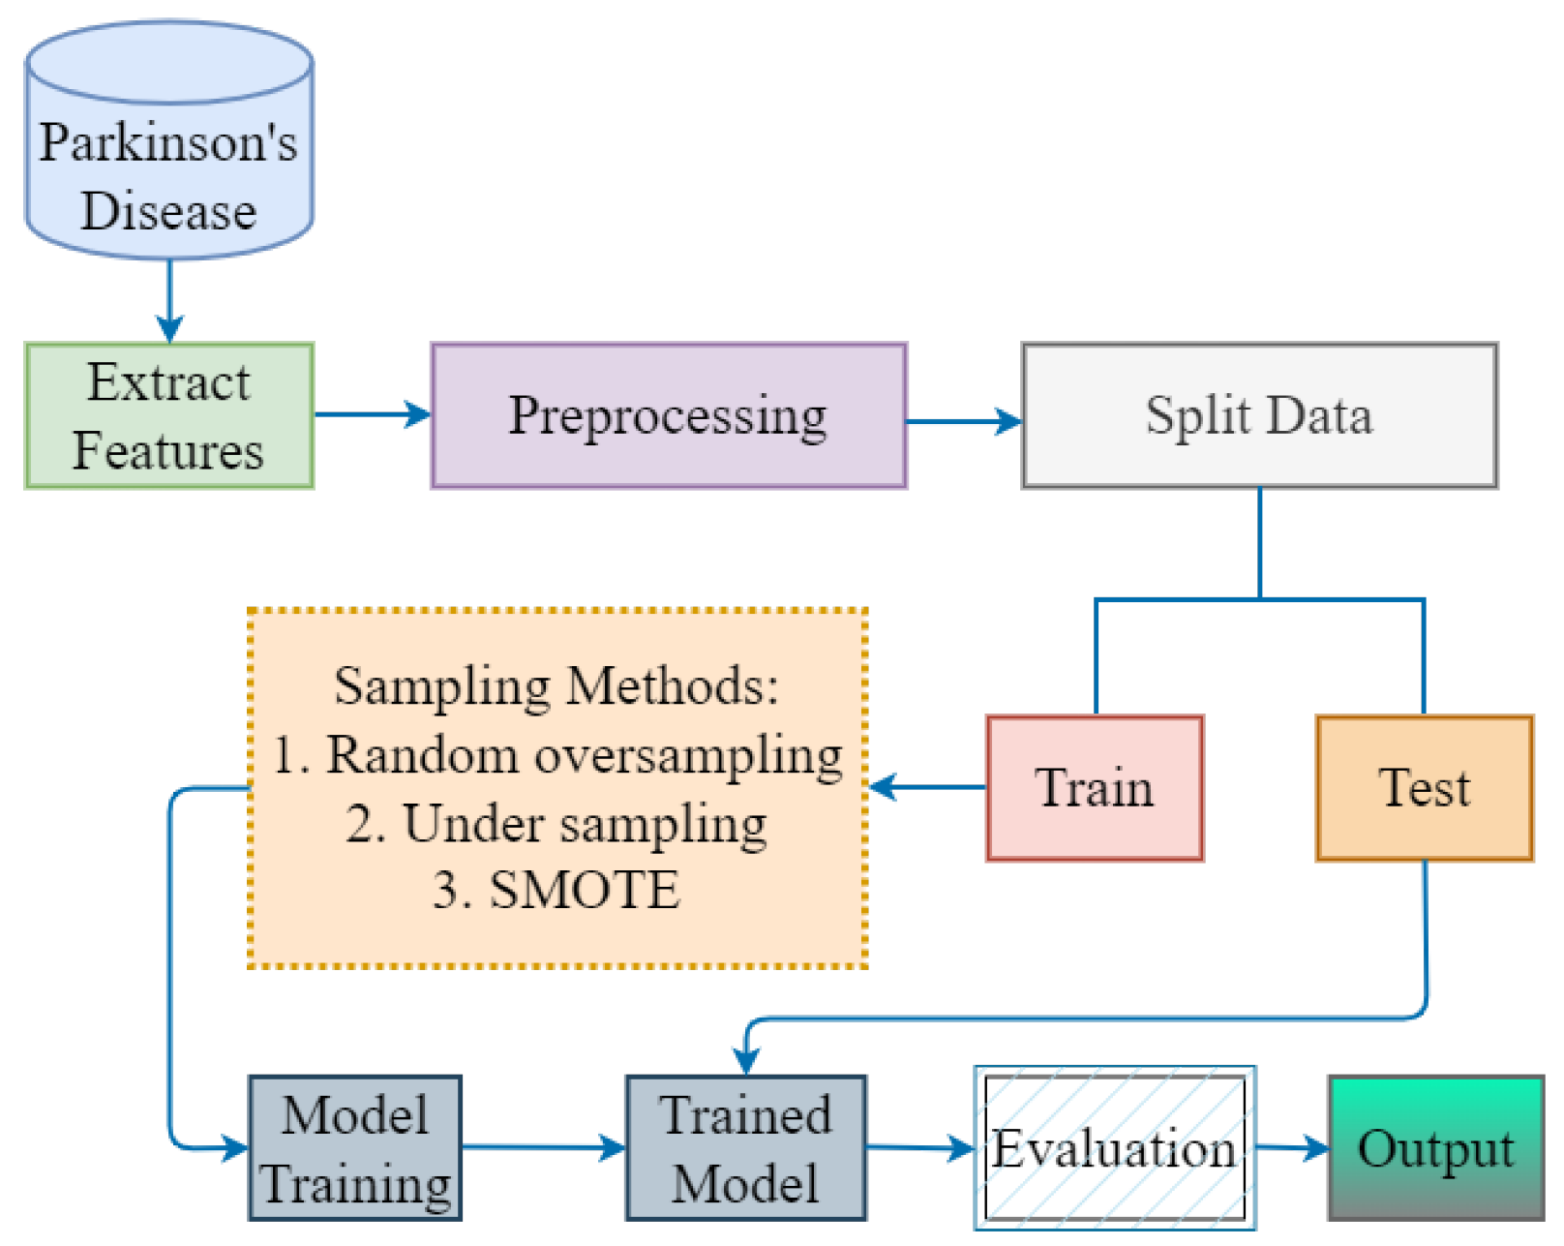

## SYSTEM REQUIREMENTS

* 1. **Software Requirements:**
* **Fronted Technology :**

**React JS , Bootstrap , Jquery**

* **Back-End Technology:**

**D-Jango, Flask , MySQL**

* **Machine Learning Model:**

**Hybrid Neural Network (CNN and LSTM)**

* **Software Development Model:**

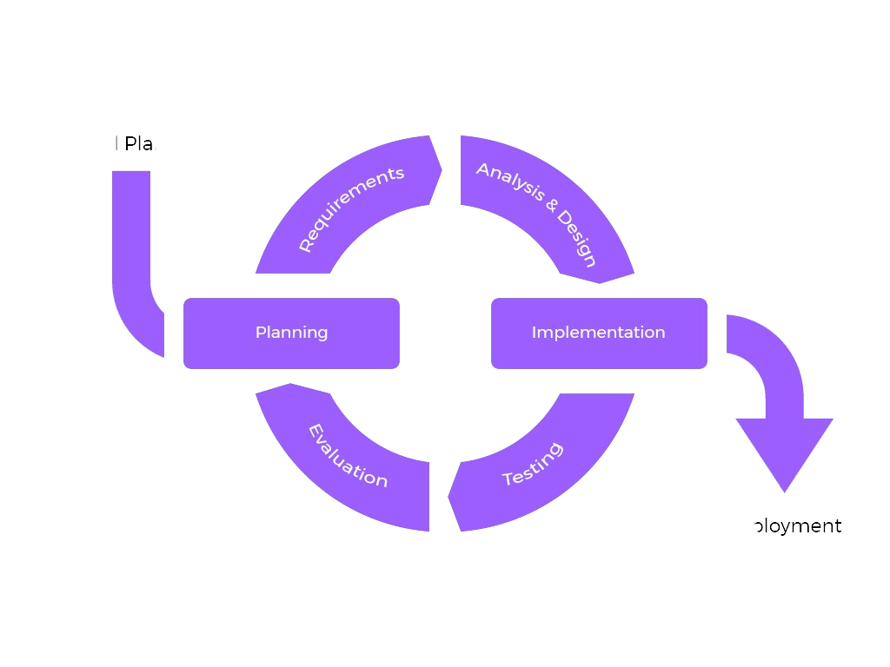

**Software Requirements**

**JUPYTER LIB**

**TENSORFLOW**

**DOCKER**

**KUBERNATES**

* 1. **Hardware Requirements:**

**Random Access Memory (RAM): 16GB - 32GB**

RAM plays a crucial role in storing and processing data during model training and inference.

With large medical imaging datasets and complex neural network architectures, a sufficient amount of RAM (16GB to 32GB) is recommended to ensure smooth execution and prevent memory-related issues.

**Graphical Processing Unit (GPU): NVIDIA GeForce RTX or equivalent**

GPUs accelerate the training and inference of deep neural networks by performing parallel computations.

For efficient training of hybrid neural network models on large medical image datasets, a dedicated GPU with CUDA support, such as NVIDIA GeForce RTX series or equivalent, is recommended.

The GPU should have a sufficient number of CUDA cores and VRAM (Video Random Access Memory) to handle the computational workload effectively.

**Central Processing Unit (CPU): Intel Core i5 (10th Gen) or equivalent**

The CPU handles general-purpose computations and system-level tasks.

An Intel Core i5 (10th Gen) processor or equivalent with multiple cores and threads provides the necessary computational power for data preprocessing, model optimization, and system management.

While the CPU's role in deep learning tasks is secondary to the GPU, having a capable CPU contributes to overall system performance and responsiveness.

**Storage: Solid State Drive (SSD)**

SSDs offer faster read/write speeds compared to traditional Hard Disk Drives (HDDs), resulting in quicker data access and model loading times.

A sufficiently large SSD with ample storage capacity is recommended to accommodate large medical image datasets, trained models, and auxiliary files.

**Additional Considerations:**

High-resolution medical images and complex neural network models may require additional hardware resources beyond the minimum specifications mentioned above.

Consideration should be given to the cooling system to prevent overheating during prolonged computational tasks.

It's advisable to have a stable power supply and adequate ventilation to ensure uninterrupted operation and prevent hardware failures.

## EXPECTED OUTCOMES

1. **Improved Diagnostic Accuracy:**
   * The hybrid neural network model enhances diagnostic accuracy by effectively integrating spatial and temporal information from medical images.
   * Achieves higher sensitivity and specificity compared to traditional methods, reducing false positives and false negatives in disease diagnosis.
2. **Multi-Disease Diagnosis Capability:**
   * Capable of diagnosing multiple diseases and medical conditions across various imaging modalities, including but not limited to cancer, cardiovascular diseases, neurological disorders, and musculoskeletal conditions.
   * Provides a versatile solution for diagnosing a wide range of medical conditions from diverse medical image datasets.
3. **Efficient Resource Utilization:**
   * Optimizes computational resources and memory usage for efficient model training and inference.
   * Maximizes utilization of hardware accelerators such as GPUs to expedite training and inference tasks, ensuring timely diagnosis and scalability.
4. **Real-Time Diagnosis Potential:**
   * Enables real-time disease diagnosis from medical images, facilitating prompt decision-making and intervention in clinical settings.
   * Supports rapid analysis of medical images for time-sensitive conditions, improving patient outcomes and treatment efficacy.
5. **Robustness to Variability:**
   * Demonstrates robust performance across different imaging modalities, disease presentations, and data quality levels.
   * Maintains consistent diagnostic accuracy under various environmental and clinical conditions, ensuring reliability in real-world applications.
6. **Interpretability and Explainability:**
   * Provides interpretable diagnostic results, allowing healthcare professionals to understand the basis of the diagnosis and trust the model's predictions.
   * Offers insights into the spatial and temporal features influencing the model's decision-making process, enhancing transparency and clinical acceptance.
7. **Scalability and Generalization:**
   * Scales effectively to handle large-scale medical image datasets and diverse disease categories.
   * Generalizes well to unseen data and clinical scenarios, demonstrating adaptability and robust performance across different healthcare settings.
8. **Clinical Validation and Adoption:**
   * Validated through rigorous testing and evaluation against gold-standard diagnostic methods and clinical expert judgments.
   * Facilitates adoption in clinical practice through regulatory approval, integration with existing healthcare systems, and user training and support.
9. **Contribution to Medical Research:**
   * Contributes to the advancement of medical imaging and diagnostic research by introducing novel methodologies and techniques.
   * Provides insights into disease pathophysiology, treatment response assessment, and prognostic prediction through comprehensive analysis of medical image data
   * .
10. **Impact on Healthcare Delivery:**
    * Improves efficiency, accuracy, and accessibility of disease diagnosis, leading to better patient outcomes, reduced healthcare costs, and improved resource allocation.
    * Empowers healthcare professionals with advanced tools and technologies to address diagnostic challenges and improve overall quality of care
    1. **conclusion:**

**Conclusion:**

1. **Accurate Disease Diagnosis:**
   * The hybrid neural network approach demonstrates promising results in achieving accurate disease diagnosis from medical images by effectively integrating spatial and temporal information.
2. **Improved Patient Outcomes:**
   * Enhanced diagnostic accuracy contributes to improved patient outcomes through timely and precise diagnosis, leading to more effective treatment strategies and better clinical management.
3. **Clinical Relevance and Acceptance:**
   * The interpretable nature of the model's predictions enhances clinical acceptance by providing insights into the features influencing the diagnosis, fostering trust and confidence among healthcare professionals.
4. **Efficient Resource Utilization:**
   * Optimized resource utilization ensures efficient model training and inference, making the proposed approach feasible for deployment in clinical settings with limited computational resources.
5. **Robustness and Generalization:**
   * The robust performance and generalization ability of the hybrid neural network model across diverse datasets and disease categories validate its applicability in real-world healthcare scenarios.
6. **Contribution to Medical Science:**
   * The research contributes to the advancement of medical imaging and diagnostic methodologies, paving the way for future innovations in disease diagnosis and treatment.

**Future Scope:**

1. **Enhanced Model Performance:**
   * Further optimization of the hybrid neural network architecture to improve model performance, reduce computational complexity, and enhance interpretability.
2. **Integration with Clinical Decision Support Systems (CDSS):**
   * Integration of the developed model with CDSS to provide decision support to healthcare professionals, aiding in clinical diagnosis and treatment planning.
3. **Multi-Modal Fusion Techniques:**
   * Exploration of advanced fusion techniques to incorporate multi-modal medical imaging data (e.g., combining MRI, CT, and PET scans) for comprehensive disease diagnosis.
4. **Continuous Model Refinement:**
   * Continuous refinement and updating of the model based on feedback from clinical validation studies, user experience, and advancements in medical imaging technology

.

1. **Clinical Trials and Regulatory Approval:**
   * Conducting clinical trials to validate the effectiveness and safety of the proposed approach in real-world clinical settings, leading to regulatory approval and widespread adoption.
2. **Personalized Medicine and Prognostic Prediction:**
   * Extension of the model to support personalized medicine approaches by integrating patient-specific data and prognostic prediction for treatment response assessment.
3. **Collaborative Research Initiatives:**
   * Collaboration with medical professionals, researchers, and industry partners to explore interdisciplinary research avenues and address emerging challenges in disease diagnosis and healthcare delivery.
4. **Ethical and Societal Implications:**
   * Consideration of ethical and societal implications related to patient privacy, data security, and algorithmic bias to ensure responsible development and deployment of AI-based diagnostic tools.

The conclusion emphasizes the significant contributions and potential impact of the proposed hybrid neural network approach on disease diagnosis from medical images, while the future scope outlines avenues for further research and development to advance the field and address evolving healthcare needs.

Top of Form

## REFERENCES

1. **Image classification using hybrid neural networks (Chih-Fong Tsai, Ken McGarry, John Tait):**
   * This research paper likely explores the use of hybrid neural networks for image classification tasks. Hybrid neural networks combine different types of neural network architectures, such as convolutional neural networks (CNNs) and recurrent neural networks (RNNs), to leverage their respective strengths in processing spatial and temporal information. The paper may discuss how hybrid neural networks can improve image classification accuracy and efficiency compared to using a single type of neural network architecture.
2. **Very Deep Convolutional Networks for Large-Scale Image Recognition (A. Zisserman, K. Simonyan):**
   * This paper introduces very deep convolutional neural networks (CNNs) for large-scale image recognition tasks. It likely discusses the architecture and training strategies for deep CNNs, such as the VGG (Visual Geometry Group) network and its variants, which have been widely used for image classification in various domains. The techniques presented in this paper could be relevant for developing robust CNN-based models for disease diagnosis from medical images.
3. **Fuzzy Logic (La Zadeh, 1988):**
   * Fuzzy logic is a mathematical framework for dealing with uncertainty and imprecision in data. This classic paper by Lotfi Zadeh introduces the concept of fuzzy logic and its applications in modeling complex systems where traditional binary logic may not be suitable. While not directly related to neural networks or medical image analysis, fuzzy logic techniques could potentially be incorporated into the development of hybrid neural network models to handle uncertainty in medical image interpretation or decision-making processes.
4. **Compressed residual-VGG16 CNN model for big data places image recognition (Hussam Quassim, Abhishek Verma, David Feinzimer):**
   * This research paper likely presents a compressed version of the VGG16 CNN model optimized for image recognition tasks in large-scale datasets. The compressed residual-VGG16 CNN model may utilize techniques such as network pruning, quantization, or knowledge distillation to reduce the model's size and computational complexity while maintaining high accuracy. The methods described in this paper could be relevant for developing efficient and scalable CNN-based models for disease diagnosis from medical images, especially when dealing with large volumes of imaging data.

Overall, these references provide valuable insights and techniques that can be leveraged in the development of Disease Diagnosis from Medical Images by Using Hybrid Neural Network. They offer a foundation for understanding neural network architectures, image classification methods, and mathematical frameworks that can enhance the accuracy and efficiency of medical image analysis tasks.

Top of Form

### 

**MAIN CODE**

import tensorflow as tf

from tensorflow.keras.models import Sequential

from tensorflow.keras.layers import Conv2D, MaxPooling2D, Flatten, Dense

from tensorflow.keras.preprocessing.image import ImageDataGenerator

import numpy as np

# Define constants

IMAGE_SIZE = (128, 128)

NUM_CLASSES = 9

BATCH_SIZE = 32

EPOCHS = 10

# Create data generators

train_datagen = ImageDataGenerator(

rescale=1./255,

shear_range=0.2,

zoom_range=0.2,

horizontal_flip=True)

test_datagen = ImageDataGenerator(rescale=1./255)

train_generator = train_datagen.flow_from_directory(

'dataset/train',

target_size=IMAGE_SIZE,

batch_size=BATCH_SIZE,

class_mode='categorical')

test_generator = test_datagen.flow_from_directory(

'dataset/test',

target_size=IMAGE_SIZE,

batch_size=BATCH_SIZE,

class_mode='categorical')

# Create model

model = Sequential([

Conv2D(32, (3, 3), activation='relu', input_shape=(IMAGE_SIZE[0], IMAGE_SIZE[1], 3)),

MaxPooling2D((2, 2)),

Conv2D(64, (3, 3), activation='relu'),

MaxPooling2D((2, 2)),

Conv2D(128, (3, 3), activation='relu'),

MaxPooling2D((2, 2)),

Flatten(),

Dense(128, activation='relu'),

Dense(NUM_CLASSES, activation='softmax')

])

# Compile model

model.compile(optimizer='adam',

loss='categorical_crossentropy',

metrics=['accuracy'])

# Train model

model.fit(

train_generator,

steps_per_epoch=train_generator.samples // BATCH_SIZE,

epochs=EPOCHS,

validation_data=test_generator,

validation_steps=test_generator.samples // BATCH_SIZE

)

# Save model

model.save('skin_Diagnose.h5')

# Function to define membership functions for fuzzy logic

def membership_functions(probabilities):

memberships = []

for prob in probabilities:

if prob <= 0.3:

memberships.append(0)

elif prob > 0.3 and prob <= 0.7:

memberships.append((prob - 0.3) / 0.4)

else:

memberships.append(1)

return memberships

# Function to perform fuzzy inference

def fuzzy_inference(memberships):

return np.argmax(memberships)

# Evaluate model on test data

test_loss, test_accuracy = model.evaluate(test_generator)

# Get predictions on test data

predictions = model.predict(test_generator)

# Apply fuzzy logic to predictions

fuzzy_predictions = []

for prediction in predictions:

memberships = membership_functions(prediction)

fuzzy_prediction = fuzzy_inference(memberships)

fuzzy_predictions.append(fuzzy_prediction)

# Evaluate fuzzy predictions

# You can perform further evaluation or analysis here based on your requirements

***Package.json file***

{

"name": "47major",

"version": "1.0.0",

"description": "",

"main": "index.js", "scripts": {

"test": "echo \"Error: no test specified\" && exit 1"

},

"keywords": [],

"author": "",

"license": "ISC", "dependencies": { "cloudinary": "^1.41.3",

"connect-flash": "^0.1.1",

"dotenv": "^16.3.2",

"ejs": "^3.1.9",

"ejs-mate": "^4.0.0",

"express": "^4.18.2",

"express-session": "^1.17.3",

"joi": "^17.11.0",

"method-override": "^3.0.0",

"mongoose": "^8.0.3",

"multer": "^1.4.5-lts.1",

"multer-storage-cloudinary": "^4.0.0", "passport": "^0.7.0",

"passport-local": "^1.0.0",

"passport-local-mongoose": "^8.0.0"

}

[Full code git-hub link...](https://github.com/11jayakbari/publicmain.git)